Portable Power Station

Model NO.: EE1000-1024Wh-2YE

Product Instruction Manual
Please read the instructions carefully before use and follow the instructions
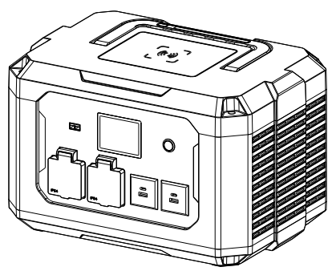

CEA Electric Co., Ltd
CONTENT
I. Product Use and Function Introduction 1
Ⅱ. Product Introduction 2
1. Product Main Structure Composition 2
2. Panel Function Description 2-4
Ⅲ. Technical Parameter 5
Ⅳ. Operation and Usage 6
1. Steps for the First Start of Portable Power Station 6
2. Charging Steps 6-7
3. USB/Wireless/AC Output Onload Usage： 7
Ⅴ. Product Maintenance 8
Ⅵ. Common Troubleshooting 8-10
Ⅶ. Warnings and Precautions 10-12
Ⅷ. Product packing list 12

Ⅰ. Product Use and Function Introduction
- Product name: Potable Power Station
- Model/Specification: EE1000-1024Wh-2YE
- Application and function introduction: Transform LiFePO4 DC to AC sine wave by inverter. With the internal bilateral inverter inside, when the product is out of power, it can be charged by mains and PV. Without Mains, this product can output AC to charge devices with corresponding power such as fans and lighting. Also, the product is designed with USB-A, USB-C output, and wireless charging for phone power. The 2.8-inch LCD screen shows battery power, input, and output.

II. Product Introduction
- Product Main Structure Composition

The portable power station mainly comprises a plastic shell, a bilateral inverter, a display, a LiFePO4 battery pack, and MPPT.

2. Panel Function Description
2.1 Front Panel

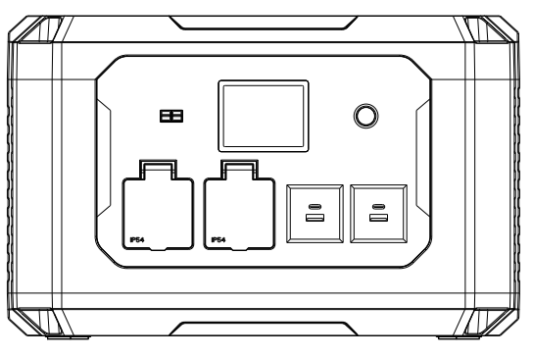
Power
PV Input
AC Output
USB-A USB-C Output
Display
2.2 Rear Panel
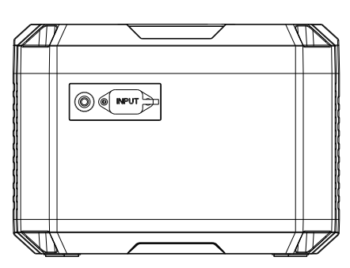
Input Overload Protection

AC Input
2.3 Left Side
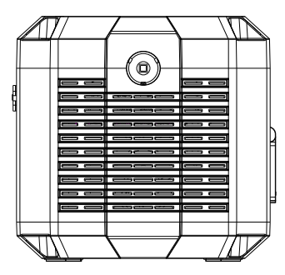
LED Lighting

2.4 Top

LED Lighting Switch

Wireless Charging

III. Technical Parameters
Item |  | Parameter
Nominal Power |  | 1000W
Peak Power |  | 2000W
Battery Parameters |  | LiFePO4 25.6V 40AH
Product Size |  | 378*265*239mm
Product Weight
Ambient Temperature Range |  | -10-40℃ Relative humidity：≤80% Altitude≤2000 Meter
Transport and Storage Environment |  | Temperature: -15-55℃  Relative humidity: ≤93% (no condensation) Atmospheric pressure：70kPa～106kPa
LED Lighting |  | 2W
Wireless Charging |  | 15W
Input | PV Charging | 10-40V 10A 400W With MPPT 5521 Port
Input | Mains Charging | AC 220-240V 900W
AC Output |  | 230V 50Hz British/European/Universal Socket (Optional)
Charging Time | PV Charging | About 3.8H（400W）
Charging Time | Charger | About 1.3H（900W）

IV. Operation and Usage

1. Steps for the First Start of Portable Power Station：
1. Check whether there is any visible damage to the station’s appearance and whether the output interfaces are loose or damaged (If abnormal conditions occur, stop using).
2. Press the “POWER” button on the front panel, and if the green light comes on, it indicates that the startup has been successful. Observe the screen to see whether the battery is fully charged. When the battery level is below 30%, it is recommended to fully charge it before use.

2. Charging Steps：
2.1 Mains Charging: First, confirm whether the mains parameter is matched with that of the machine. Then, turn on the power, and confirm that there is no load on the AC output socket. Plug the equipped power cord to the DC port on the back of the machine and the other end to the mains power socket. And check the power change on the screen. The rise shows that the machine has been powered successfully.
2.2 Solar photovoltaic charging： Please check the photovoltaic input voltage range before charging. Turn on the power, and after confirming that the positive and negative poles of the input interface correspond correctly to the positive and negative poles on the product socket, insert the input interface into the 5521 photovoltaic charging socket on the machine. And check the power change on the screen. The rise shows that the machine has been powered successfully.
3. AC Output On-load Usage：
Before use, please check that the power range and voltage range of the on-load electrical equipment should match the output parameters of the station. Turn on the power, and insert the power plug of the loaded product into the output socket at the front of the station. The load should work normally.

- USB Output On-load Usage：
Turn on the Power. Plug the USB to the USB-A or USB-C port. The load shall work normally this time.
- Wireless Charging:
Turn on the power. Put the mobile phone with the wireless charging function into the wireless charging induction area on the top of the product. Then the phone may be charged normally.
- LED Lighting Usage:
Turn on the power. Pressing the switch at the handle, the light will on. The first pressing leads to light; the second to flash; and the third to light off.
V、Product Maintenance
5.1 Newly products should be fully charged before use;
5.2 Regularly remove dust and dirt from the heat dissipation window；
5.3 In the case of long-term storage for more than three months, not less than 50% of the power storage shall be maintained;
5.4 If stored for more than 6 months, to extend the service life of the battery, please charge and discharge the product 1-2 times;
Ⅵ、Common Troubleshooting

6.1 Unable to Perform Mains Charging:

A、Confirm whether the mains parameter is matched with the machine;

B、Power should be on;

C、Check whether the power cord is broken or in an open circuit

D、When charging, the AC output socket should not be plugged into the load, otherwise it cannot start charging;

6.2 Unable to Perform Photovoltaic Charging

A、Check whether the voltage range and current of the photovoltaic panel are within the parameter range of the power station.

B、Make sure to use it in sufficient light.

C、Before PV charging, the POWER switch should be turned on so that the power station can be charged under the startup status.

D、Check whether the positive and negative poles of PV wires correspond to those on the machine socket and match with plugs and sockets.

E、Check whether the PV wires are broken or in an open circuit.

6.3 Unable to Perform AC Load:

A、Confirm whether the power of the load appliance is within the normal load range of the power station.

6.4 After turning on the main power switch of the power station, the product cannot start normally and the display screen doesn’t work:

A、The product battery may be out of power, the internal inverter cannot be started, and the battery enters a state of power loss sleep. You can first access the charger to charge the product and activate it. When the battery is fully charged, it can be used.

6.5 Why does the output shut off when the battery power is 10%?

A、The system is set to turn off the output when the battery power is ≤10%. This is to protect the battery cell from over-discharge. When this situation occurs, the battery should be charged immediately;

6.6 Wireless Charging Function Failure:

A. Confirm whether the mobile phone supports wireless charging;

B. The back of the phone should be flat. There should be no gap between the wireless charging induction area and the phone back;

C. When applying the wireless charging function, the power should be on.
Ⅶ、Warnings and Precautions
7.1 Different electrical appliances have different voltage standards. Before use, please carefully check whether the rated voltage range of the product is consistent with the voltage range of the portable power station, otherwise, it may lead to dangerous situations;
7.2 After the battery is discharged to the cut-off voltage, continuing to discharge is called over-discharge. It can easily cause serious power loss in the battery, thereby greatly shortening its service life. Therefore, deep discharge should be avoided as much as possible when using the battery;
7.3 The product should be kept away from fire, high-temperature environments, and humid and rainy environments during use and storage, otherwise it may lead to dangerous situations;
7.4 This product has a built-in high-voltage power supply, and non-professionals should not disassemble it by themselves;
7.5 Do not discard the product at the end of its service life. Recycle the product according to local laws and regulations;
7.6 Do not discard the product at the end of its service life. Recycle the product according to local laws and regulations;
7.7 It cannot be used at an altitude exceeding 2000m;
7.8 The product is AC output. Please do not insert your hands or hand-held metal conductors into the AC socket；
7.9 Do not drop, squeeze, or collide with the product, so as not to subject the product to external pressure, which may cause a short circuit of the internal circuit of the product and damage to the battery；
7.10 After use, please turn off the machine in time (the no-load power consumption will continue to consume battery power when the machine is on)；
7.11 Please select solar panels according to the specified electrical parameters. If the voltage is above these parameters, it may damage the product；
7.12 Please charge the product with an equipped charger.
7.13 This product and its accessories may contain some small parts. Please keep the product and its accessories out of the reach of children. Children may accidentally damage the product and its accessories, or swallow small parts, causing suffocation or other dangers, children or people with mental retardation need to use this product accompanied by their guardians；
7.14 Do not use the product during thunderstorms. This may cause product failure or electric shock；
7.15 If the product accidentally falls into the water during use, place it in a safe open area and do not turn it on again；
7.16 To avoid power loss, the product should be recharged immediately after use;
7.17 If any fault occurs during the use of the product, it should be stopped immediately.
7.18 The input on the back is the AC one. Please do not use DC power with it otherwise, the product will be damaged.

Ⅷ、Product packing list
8.1 portable power station*1
8.2 product manual*1
8.3 power cord*1
Production Address: No. 6, Yingyang Road, Yingquan District, Fuyang City,Anhui Province
Phone: 0558-7159979
Fax: 0558-7159988
Postcode: 236000
Date of manufacture: Please refer to the package.
Service life：3 years
The date of compilation of the manual：2024.6.24

